Name: R Priya Dharshini
Roll: CH.SC.U4CYS25026
ACTIVITY-2

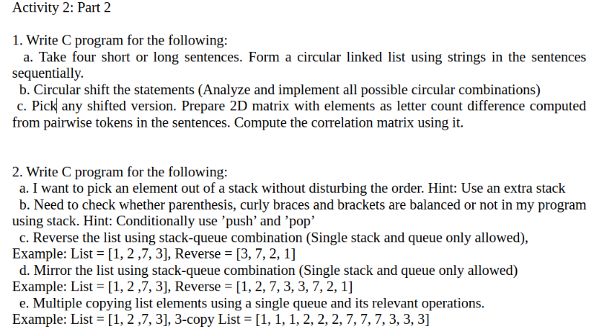
ANSWER 1(a):
#include <stdio.h>
#include <stdlib.h>
#include <string.h>

/*
=========================================================
PROGRAM:
Create a Circular Linked List using four sentences.

OBJECTIVE:
1. Accept four sentences from the user.
2. Store each sentence in a node.
3. Connect the last node to the first node.
4. Display the circular linked list.

DATA STRUCTURE:
Circular Singly Linked List

TIME COMPLEXITY:
Insertion : O(n)
Traversal : O(n)

SPACE COMPLEXITY:
O(n)
=========================================================
*/

/* Structure representing a node in the circular linked list */
struct Node
{
char sentence[200]; // Stores one complete sentence
struct Node *next; // Stores address of next node
};

/* Function to create a new node */
struct Node* createNode(char str[])
{
/* Allocate memory dynamically */
struct Node *newNode =
(struct Node*)malloc(sizeof(struct Node));

/* Copy sentence into node */
strcpy(newNode->sentence, str);

/* Initially next pointer is NULL */
newNode->next = NULL;

return newNode;
}

/* Function to display circular linked list */
void display(struct Node *head)
{
/* If list is empty */
if(head == NULL)
{
printf("List is Empty\n");
return;
}

struct Node *temp = head;

printf("\nCircular Linked List Contents:\n");

/*
Traverse until we reach
the starting node again
*/
do
{
printf("%s\n", temp->sentence);

temp = temp->next;

} while(temp != head);
}

int main()
{
struct Node *head = NULL;
struct Node *tail = NULL;

char input[4][200];

printf("Enter 4 Sentences:\n");

/* Read four sentences */
for(int i=0;i<4;i++)
{
fgets(input[i],200,stdin);

/* Remove newline character */
input[i][strcspn(input[i],"\n")] = '\0';

/* Create node */
struct Node *newNode =
createNode(input[i]);

/*
If first node,
initialize head and tail
*/
if(head == NULL)
{
head = tail = newNode;
}
else
{
/*
Attach new node
after current tail
*/
tail->next = newNode;

/* Update tail */
tail = newNode;
}
}

/*
Connect last node to first node
to make list circular
*/
tail->next = head;

display(head);

printf("\nProgram Executed Successfully\n");

return 0;
}

OUTPUT
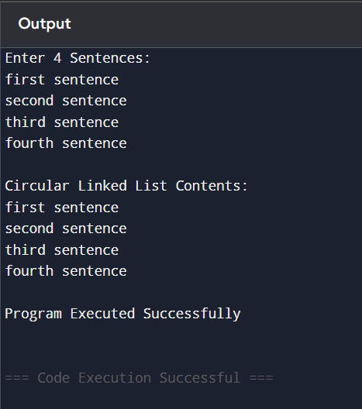

ANSWER 1(b):
#include <stdio.h>
#include <string.h>

/*
=========================================================
PROGRAM:
Generate all possible circular shifts of 4 sentences.

OBJECTIVE:
1. Accept four sentences.
2. Rotate sentences circularly.
3. Display every possible circular arrangement.

EXAMPLE:

Original:
S1
S2
S3
S4

Shift 1:
S2
S3
S4
S1

Shift 2:
S3
S4
S1
S2

Shift 3:
S4
S1
S2
S3

TIME COMPLEXITY:
O(n²)

SPACE COMPLEXITY:
O(n)
=========================================================
*/

int main()
{
char sentence[4][200];

printf("Enter 4 Sentences:\n");

/* Read all four sentences */
for(int i=0;i<4;i++)
{
fgets(sentence[i],200,stdin);

/* Remove newline character */
sentence[i][strcspn(sentence[i],"\n")] = '\0';
}

printf("\nAll Possible Circular Shifts:\n");

/*
Outer loop controls
the amount of rotation
*/
for(int shift=0; shift<4; shift++)
{
printf("\nShift %d:\n",shift);

/*
Print sentences in
circular shifted order
*/
for(int i=0;i<4;i++)
{
/*
Modulus operator (%)
automatically wraps
index back to beginning
*/
printf("%s\n",
sentence[(i+shift)%4]);
}
}

printf("\nProgram Executed Successfully\n");

return 0;
}

OUTPUT:
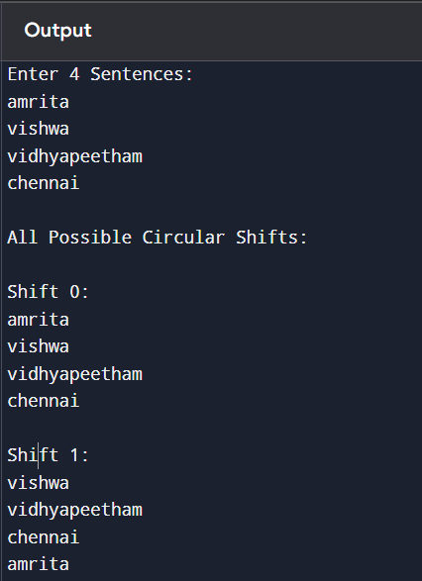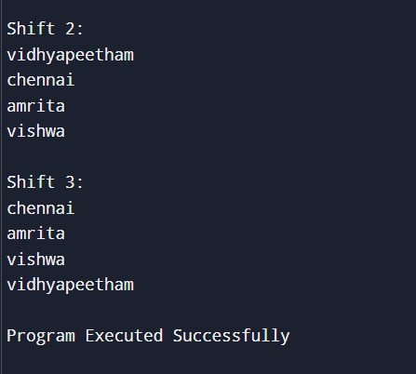

ANSWER 1(c):
#include <stdio.h>
#include <string.h>
#include <stdlib.h>

/*
=========================================================
PROGRAM:
Difference Matrix and Correlation Matrix

OBJECTIVE:
1. Read 4 sentences.
2. Calculate length of each sentence.
3. Create Difference Matrix using
|Length(i) - Length(j)|.
4. Create Correlation Matrix using
1/(1 + Difference).
5. Display both matrices.

TIME COMPLEXITY : O(n²)
SPACE COMPLEXITY: O(n²)
=========================================================
*/

int main()
{
char sentence[4][200];

int length[4];

int difference[4][4];

float correlation[4][4];

printf("Enter 4 Sentences:\n");

/* Read 4 sentences */
for(int i = 0; i < 4; i++)
{
fgets(sentence[i], sizeof(sentence[i]), stdin);

/* Remove newline character */
sentence[i][strcspn(sentence[i], "\n")] = '\0';
}

/* Find length of each sentence */
for(int i = 0; i < 4; i++)
{
length[i] = strlen(sentence[i]);
}

/* Build Difference Matrix */
for(int i = 0; i < 4; i++)
{
for(int j = 0; j < 4; j++)
{
difference[i][j] =
abs(length[i] - length[j]);
}
}

/* Build Correlation Matrix */
for(int i = 0; i < 4; i++)
{
for(int j = 0; j < 4; j++)
{
correlation[i][j] =
1.0f / (1 + difference[i][j]);
}
}

printf("\nLength of Sentences:\n");

for(int i = 0; i < 4; i++)
{
printf("Sentence %d Length = %d\n",
i + 1, length[i]);
}

printf("\nDifference Matrix:\n");

for(int i = 0; i < 4; i++)
{
for(int j = 0; j < 4; j++)
{
printf("%4d ", difference[i][j]);
}
printf("\n");
}

printf("\nCorrelation Matrix:\n");

for(int i = 0; i < 4; i++)
{
for(int j = 0; j < 4; j++)
{
printf("%.2f ", correlation[i][j]);
}
printf("\n");
}

printf("\nProgram Executed Successfully\n");

return 0;
}

OUTPUT:
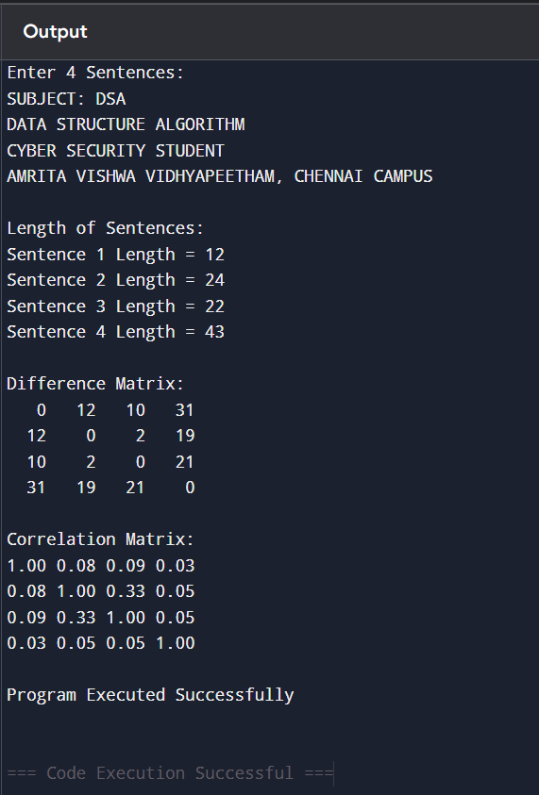

ANSWER 2(a):
#include <stdio.h>

#define MAX 100

/*
=========================================================
PROGRAM:
Access an element from stack without disturbing order.

OBJECTIVE:
1. Store elements in stack.
2. Access any position from top.
3. Restore original stack order.

CONCEPT:
Use an auxiliary stack.

TIME COMPLEXITY:
O(n)

SPACE COMPLEXITY:
O(n)
=========================================================
*/

int stack[MAX];
int top=-1;

/* Push operation */
void push(int value)
{
stack[++top]=value;
}

/* Pop operation */
int pop()
{
return stack[top--];
}

int main()
{
int n;

printf("Enter Number of Elements: ");
scanf("%d",&n);

printf("Enter Stack Elements:\n");

/* Insert elements */
for(int i=0;i<n;i++)
{
int x;

scanf("%d",&x);

push(x);
}

int position;

printf("Position from Top: ");
scanf("%d",&position);

int temp[MAX];

int tempTop=-1;

/*
Move elements above
required position
into temporary stack
*/
for(int i=1;i<position;i++)
{
temp[++tempTop]=pop();
}

/*
Required element
now appears at top
*/
int required = stack[top];

/*
Restore original order
*/
while(tempTop!=-1)
{
push(temp[tempTop--]);
}

printf("Required Element = %d\n",
required);

printf("\nProgram Executed Successfully\n");

return 0;
}

OUTPUT:
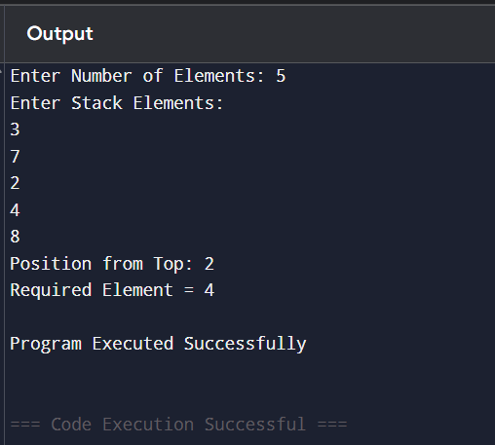

ANSWER 2(b):
#include <stdio.h>
#include <string.h>

/*
=========================================================
PROGRAM:
Balanced Parentheses Checker using Stack

OBJECTIVE:
1. Accept a complete expression/sentence.
2. Check whether (), {} and [] are balanced.
3. Display Balanced or Not Balanced.

DATA STRUCTURE:
Stack

TIME COMPLEXITY:
O(n)

SPACE COMPLEXITY:
O(n)
=========================================================
*/

/* Stack declaration */
char stack[100];

int top = -1;

/* Push operation */
void push(char ch)
{
stack[++top] = ch;
}

/* Pop operation */
char pop()
{
return stack[top--];
}

/* Function to check matching brackets */
int match(char open, char close)
{
return (open == '(' && close == ')') ||
(open == '{' && close == '}') ||
(open == '[' && close == ']');
}

int main()
{
char exp[200];

printf("Enter Expression: ");

/* Read complete sentence including spaces */
fgets(exp, sizeof(exp), stdin);

/* Remove newline character */
exp[strcspn(exp, "\n")] = '\0';

/* Scan entire expression */
for(int i = 0; exp[i] != '\0'; i++)
{
/* Push opening brackets */
if(exp[i] == '(' ||
exp[i] == '{' ||
exp[i] == '[')
{
push(exp[i]);
}

/* Process closing brackets */
else if(exp[i] == ')' ||
exp[i] == '}' ||
exp[i] == ']')
{
/* No matching opening bracket */
if(top == -1)
{
printf("\nNot Balanced Expression\n");
return 0;
}

/* Check matching pair */
if(!match(pop(), exp[i]))
{
printf("\nNot Balanced Expression\n");
return 0;
}
}
}

/* If stack is empty, all brackets matched */
if(top == -1)
{
printf("\nBalanced Expression\n");
}
else
{
printf("\nNot Balanced Expression\n");
}

printf("\nProgram Executed Successfully\n");

return 0;
}

OUTPUT:
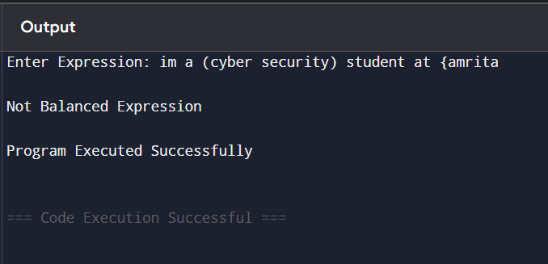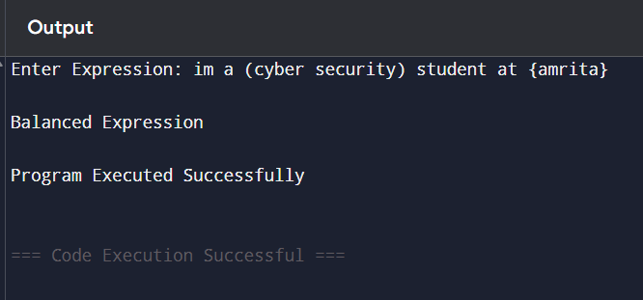

ANSWER 2(c):
#include <stdio.h>

/*
=========================================================
PROGRAM:
Reverse a List using One Stack and One Queue

OBJECTIVE:
1. Read list elements.
2. Store elements in queue.
3. Transfer elements to stack.
4. Print stack elements.
5. Obtain reverse order.

TIME COMPLEXITY:
O(n)

SPACE COMPLEXITY:
O(n)
=========================================================
*/

int main()
{
int n;

printf("Enter Number of Elements: ");
scanf("%d",&n);

/* Queue representation */
int queue[100];

/* Stack representation */
int stack[100];

int top = -1;

printf("Enter Elements:\n");

/*
Read elements into queue
maintaining original order
*/
for(int i=0;i<n;i++)
{
scanf("%d",&queue[i]);
}

/*
Transfer elements from queue
into stack

Stack automatically reverses
order because of LIFO property
*/
for(int i=0;i<n;i++)
{
stack[++top] = queue[i];
}

printf("\nReversed List:\n");

/*
Pop elements from stack
to obtain reverse order
*/
while(top!=-1)
{
printf("%d ",stack[top--]);
}

printf("\n\nProgram Executed Successfully\n");

return 0;
}

OUTPUT:
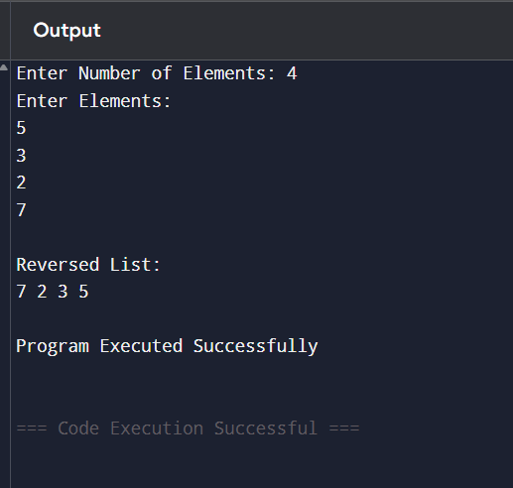

ANSWER 2(d):
#include <stdio.h>

/*
=========================================================
PROGRAM:
Generate Mirror List

OBJECTIVE:
Create a mirror image of a list.

EXAMPLE:

Input:
1 2 7 3

Output:
1 2 7 3 3 7 2 1

TIME COMPLEXITY:
O(n)

SPACE COMPLEXITY:
O(n)
=========================================================
*/

int main()
{
int n;

printf("Enter Number of Elements: ");
scanf("%d",&n);

int queue[100];
int stack[100];

int top=-1;

printf("Enter Elements:\n");

/*
Store elements in queue
and simultaneously push
into stack
*/
for(int i=0;i<n;i++)
{
scanf("%d",&queue[i]);

stack[++top]=queue[i];
}

printf("\nMirror List:\n");

/*
Print original sequence
*/
for(int i=0;i<n;i++)
{
printf("%d ",queue[i]);
}

/*
Print reverse sequence
obtained from stack
*/
while(top!=-1)
{
printf("%d ",stack[top--]);
}

printf("\n\nProgram Executed Successfully\n");

return 0;
}

OUTPUT:
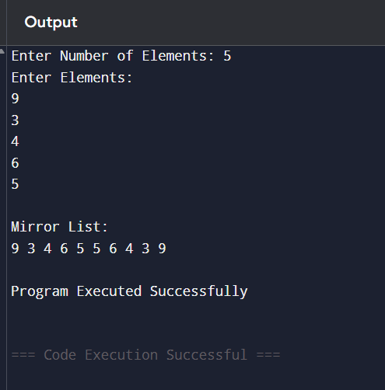

ANSWER 2(e):
#include <stdio.h>

/*
=========================================================
PROGRAM:
Multiple Copy List

OBJECTIVE:
Create three copies of every
element in the given list.

EXAMPLE:

Input:
1 2 7 3

Output:
1 1 1 2 2 2 7 7 7 3 3 3

TIME COMPLEXITY:
O(n × k)

SPACE COMPLEXITY:
O(1)

where k = number of copies
=========================================================
*/

int main()
{
int n;

printf("Enter Number of Elements: ");
scanf("%d",&n);

int arr[100];

printf("Enter Elements:\n");

/*
Read all elements
into array
*/
for(int i=0;i<n;i++)
{
scanf("%d",&arr[i]);
}

printf("\nMultiple Copy List:\n");

/*
Traverse every element
*/
for(int i=0;i<n;i++)
{
/*
Print each element
three times
*/
for(int j=0;j<3;j++)
{
printf("%d ",arr[i]);
}
}

printf("\n\nProgram Executed Successfully\n");

return 0;
}

OUTPUT:
